Name/ احمد محمد إبراهيم محمد

Code/ECE001

B-N/ 110

TOPIC/ ARTIFICIAL INTELLIGENCE

Link/[file:///C:/Users/Ahmad/OneDrive/Desktop/html.project/mainpage.html](file:///C:\Users\Ahmad\OneDrive\Desktop\html.project\mainpage.html)

APPLICATION BRIEF/

SCREENSHOTS/

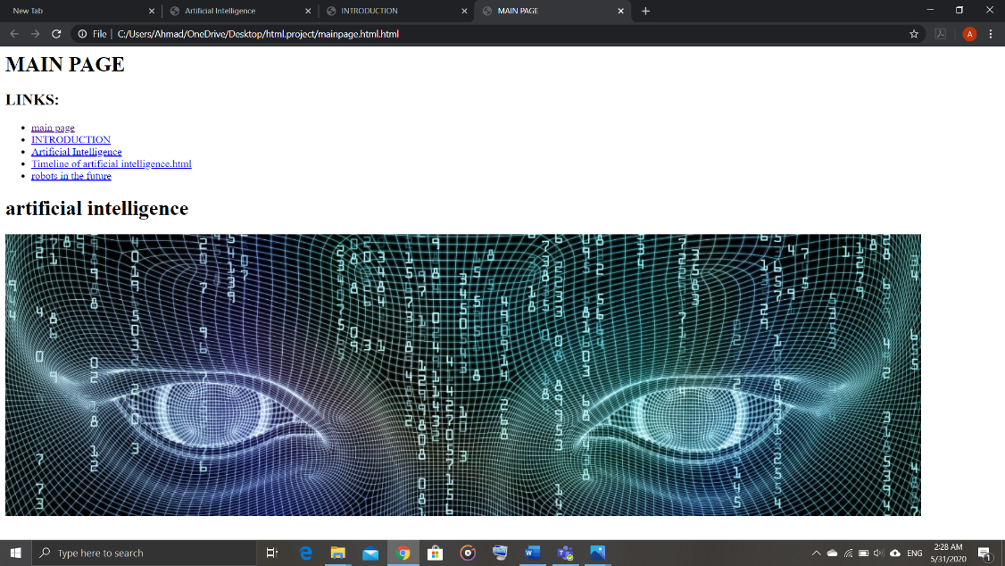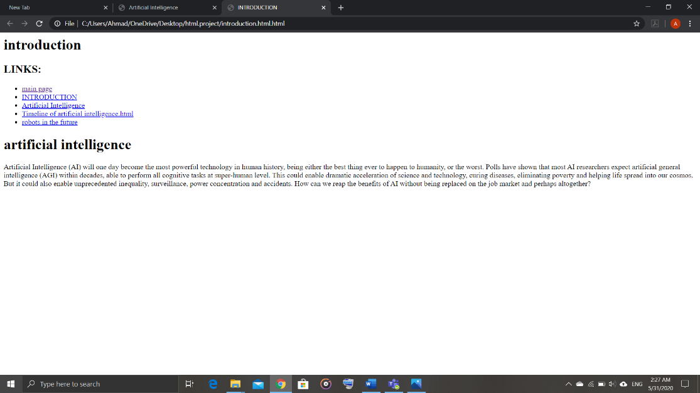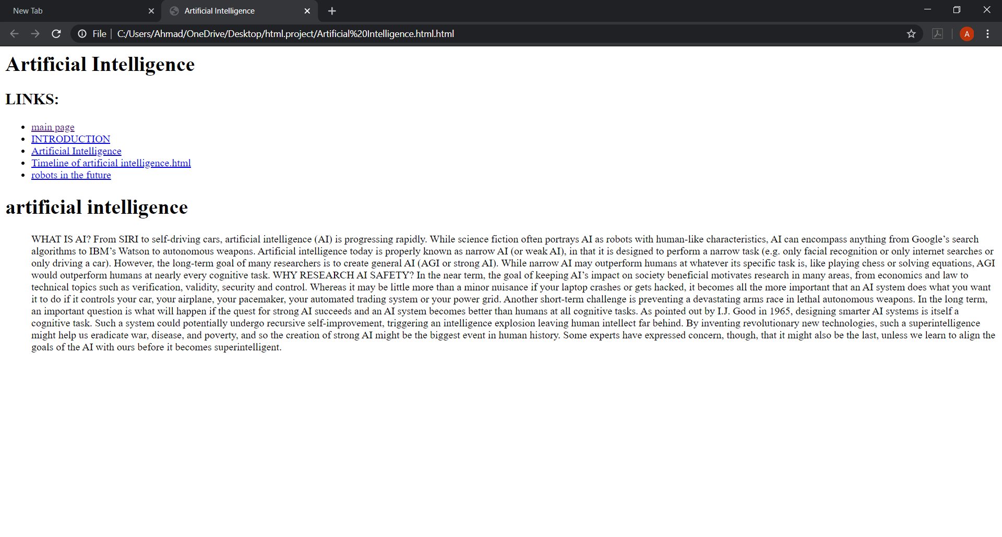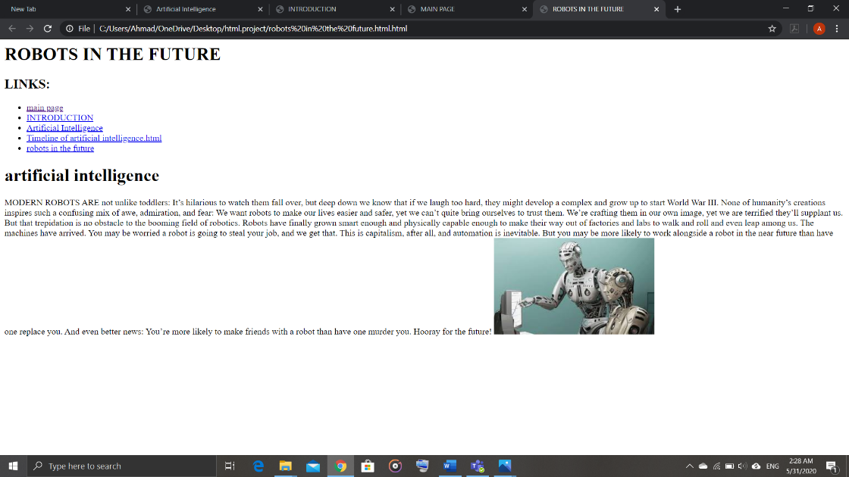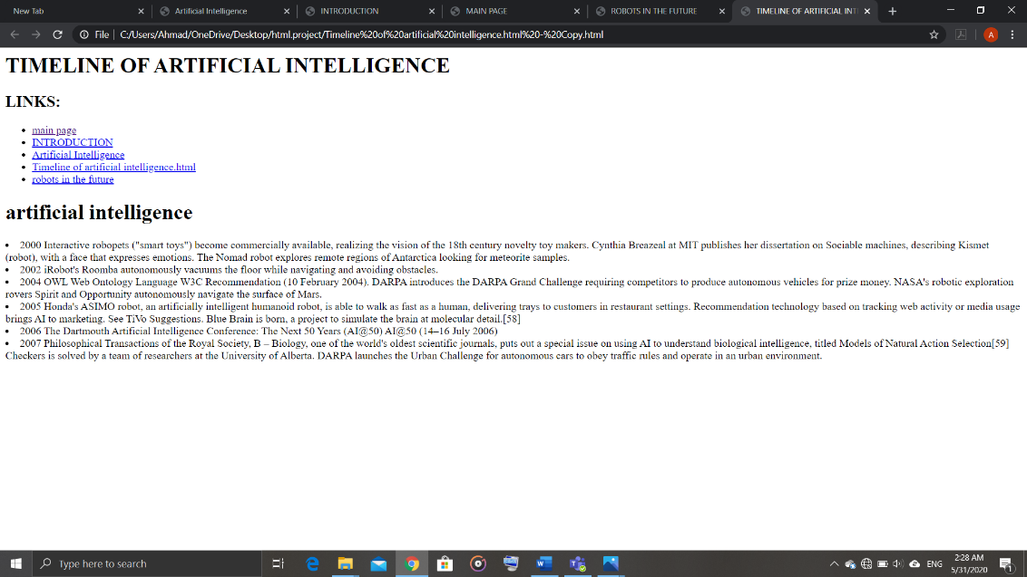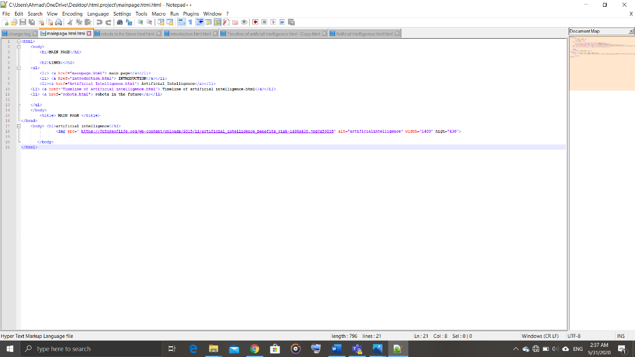

[file:///C:/Users/Ahmad/OneDrive/Desktop/html.project/mainpage.html](file:///C:\Users\Ahmad\OneDrive\Desktop\html.project\mainpage.html)